REGINALD ALEXANDER HONOUR M.M.
LANCE CORPORAL No.18320,
Ist.BATTALION COLDSTREAM GUARDS
1.9.1894-17.10.1918
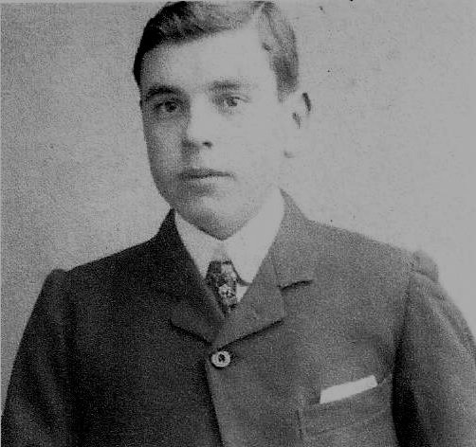

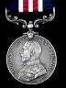
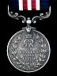
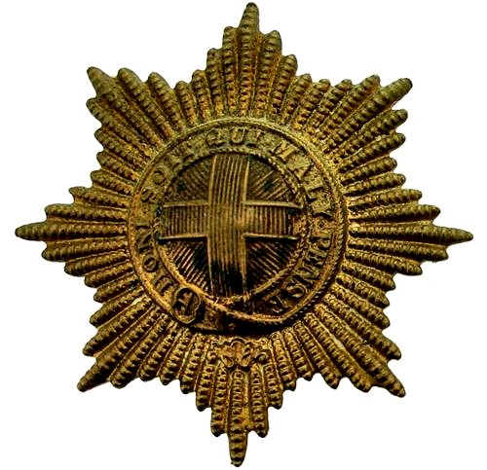
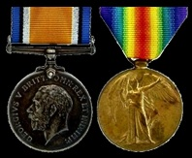
Military Medal
Coldstream Guards Cap Badge
British War Medal & Victory Medal

The Honour surname derives from the Old French word “Honore”, with the same meaning.

Reginald’s forefathers had also served their country. His grandfather was Henry Honour, 1803-1888, who served in the Shropshire Regiment of Foot, fighting in the Peninsular War of 1808-14. His battalion was the first to guard the exiled Napoleon on the island of St.Helena. After serving in India, Malta, Gibraltar, Ireland and Scotland, he retired as a Chelsea Pensioner. His wife Mary Spiers was Scottish. In Scotland her surname was originally a nickname for a tall skinny person. About 1853 the family moved to Holcombe and lived in “Vine Cottages”, now “The Ropewalk”. Henry was buried in St. Gregory’s churchyard, Dawlish and was survived by 3 sons and 3 daughters.
Reginald’s father Thomas Alexander Honour, 1850-1929 was born in Plymouth and died in Holcombe. He served in the Royal Navy, from which he received a pension. He then became a tailor and in 1911 was recorded as a farm labourer. Thomas married in 1883 Emily Drusilla Jarman, 1847-1916, the daughter of James Howe Jarman and Sarah Ann Ware, who lived across the road in Alexandra Cottages, Holcombe.
They had 2 sons:-
Bertram Charles, 1890-1916, a Private in the 2/4th.Devonshire Regiment, who died of a fever whilst serving in Madras, India. His Memorial Service was held here in St.George’s Church on 18.11.2016.
Their 2nd.son Reginald Alexander was born in “Vine Cottages”, Holcombe in 1894 and was later educated at the County Council School in Dawlish. In 1911 he was still living in Holcombe and was employed as a gardener.
1.3.1912 he married in St. Gregory’s Church, Dawlish, Susie May Hamlin.
1913 They had a son, Norman Reginald Honour and in 1916 they had a daughter, Gwendoline May Honour.
In 1916 he enlisted in Newton Abbot and on 14.4.1916 he joined, as a Private, the 1st.Battalion Coldstream Guards.
On 12.12.1916 he served in the 1st.Battalion, 2nd.Guards Brigade of the 1st. Division. Whilst still a Private, he was awarded the Military Medal.
This medal was awarded to NCOs for “Acts of gallantry and devotion to duty under fire”. It entitled him to add the initials M.M. after his surname. His award was gazetted on 21.9.1919.

During 1917 his regiment fought during the German retreat to the Hindenburg Line and from 31.7.1917-10.11.1917 at the Battle of Passchendaele.
During 1918 his regiment fought at the
Battle of Estaires, 9-11.4.1918,
Battle of Hazebrouck, 12-15.4.1918.
Battle of Bethune, 18.4.1918.
Battle of Drocourt-Queant, 2.9.1918
Battle of Epehy, 18.9.1918.
Battle of St. Quentin Canal and Beaurevoir 29.9.-10.10.1918,
Battle of the Selle, 17.10-25.10.1918.

During his service he was promoted to Lance Corporal and was in charge of the Battalion Intelligence Section.
His duties were to collate all the information supplied by observers, patrols, scouts, snipers and by his own personal observations on entering “No Man’s Land”. Additional information would be gleaned from eavesdropping equipment, communications with the Signals Corps and the Royal Flying Corps. Such information may have included enemy troop movements, the position of machine gun posts and other artillery, the state of barbed wire defences and on occasions, information supplied by captured prisoners or deserters. The collated information was then supplied on a daily basis to the battalion commander.
He may also have been responsible for writing up the daily war diary, which would then have been signed off by a senior officer.
On 17.10.1918 he was mortally wounded on the first day of the Battle of the Selle. He was removed to 29th.Casualty Clearing Station, Delsaux Farm, for medical treatment but died the same day.

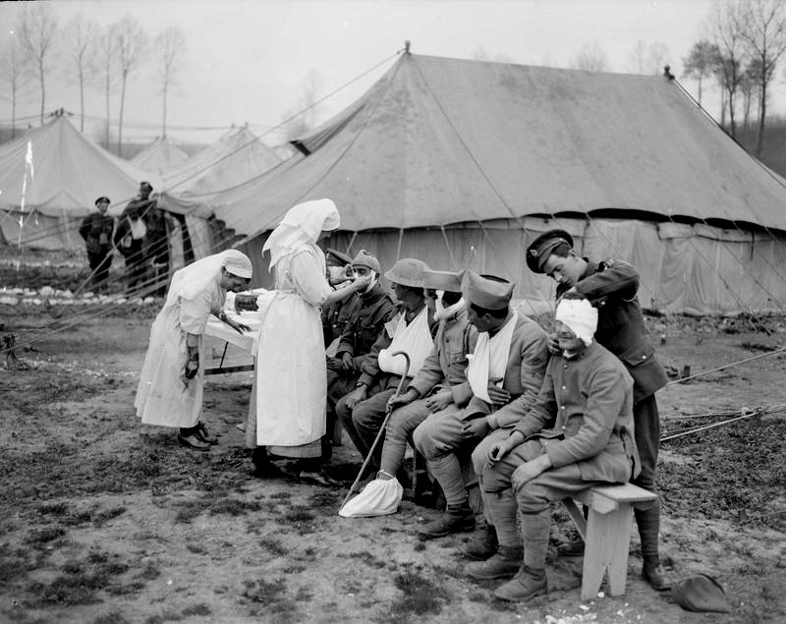
French and British troops being treated at
29 Casualty Clearing Station, Delsaux Farm, Pas de Calais, France.

This Clearing station had been established by the Royal Army Medical Corps on 5.10.1918 and continued until 14.2.1919.
His Commanding Officer wrote, “He is sadly missed, as he was one of the keenest and most hard-working N.C.O.s in the battalion.”

Reginald was buried Row 11 B 19, Delsaux Farm Cemetery.

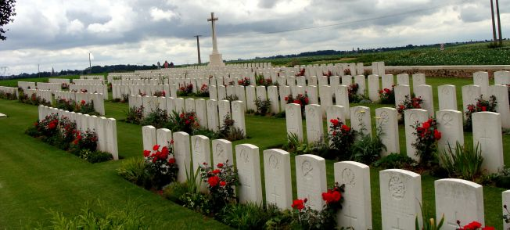
Delsaux Farm Cemetery, Beugny, Pas de Calais, France

He is also commemorated on the Dawlish War Memorial and Holcombe Village War Memorials.
The Brass War Memorial outside St.George’s Church, mis-spelled his surname as Honor, but the one inside the church is correct.

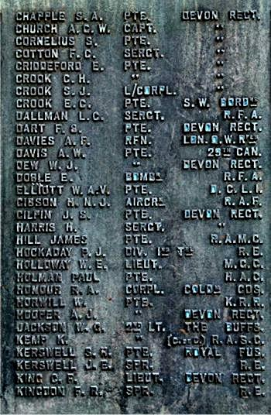

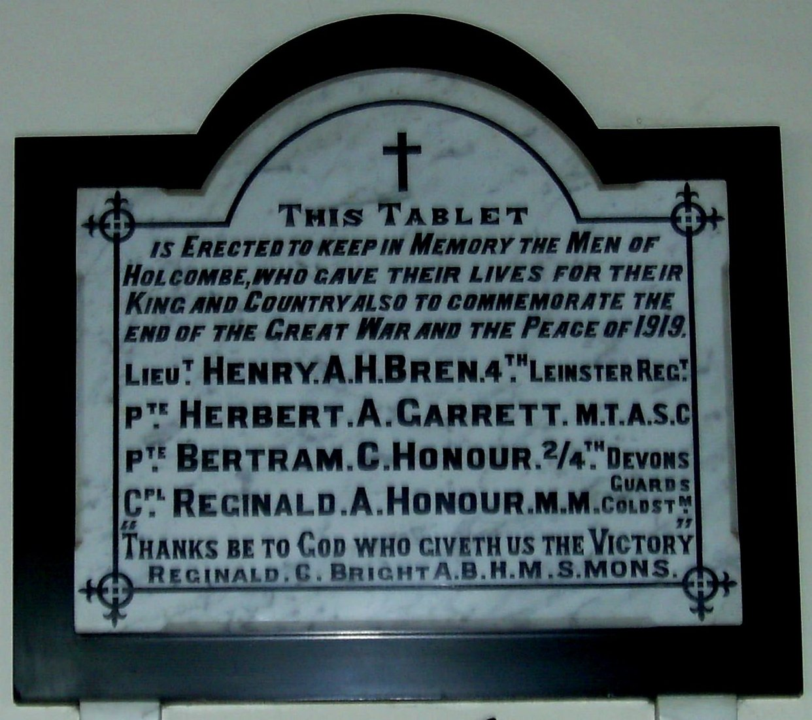

Dawlish War Memorial Holcombe War Memorial

17.10.2018

Text contributed by Campbell Brown (1947-2017)

